Assignment Bash/Terminal

Name: Anderson(Han Lin Yeh)

Data: 1/25/2025

Question 1: (10 Points)

What is the difference between shell and bash?

 Ans:

A **shell** is a command-line interface that allows users to interact with the operating system by running commands, executing scripts, and managing processes.

A bash is a kind of shell, most used in Linux and macOS systems.

Question 2: (10 Points) To respond to this question, you need to use terminal/Bash and have a screenshot of your terminal/bash.

1. What is your home directory?

Ans: /c/Users/user

1. What files/folders exist in it?

Ans:

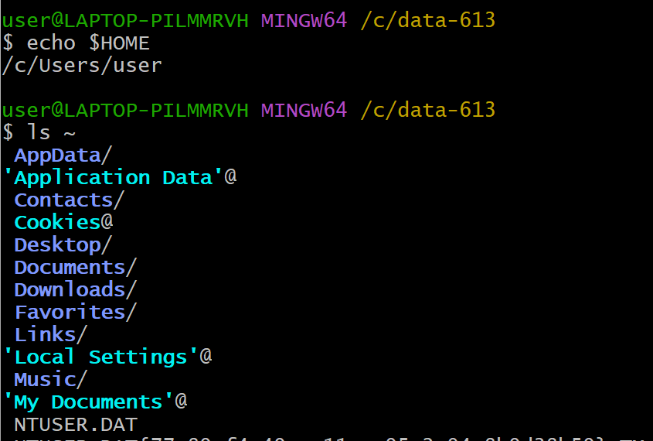

Question 3: (10 Points)  To respond to this question, you need to use terminal/Bash and have a screenshot of your terminal/bash.

1. Where does the command `cd../../` take you? Run the command `pwd` and explain the output!

Ans: The command `cd../../` moves up to two levels in the directory path. The command `pwd` shows the current path.

1. What does the command `cd` do? Run the command `pwd` and explain the output!

 Ans: The command `cd` takes me to the my home directory. The command `pwd` shows the current path.

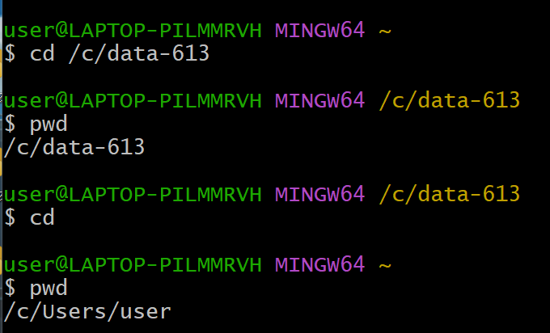

Question 4: (10 Points)  To respond to this question, you need to use terminal/Bash and have a screenshot of your terminal/bash.

Read the manual page of ls. What does the `a` flag do? What does the `l` flag do?

 Ans: 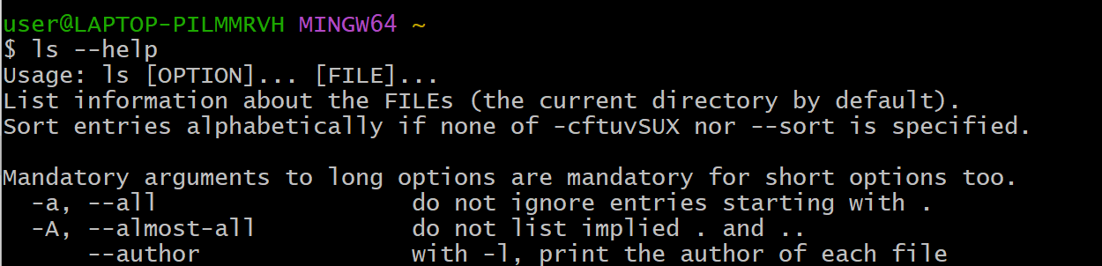

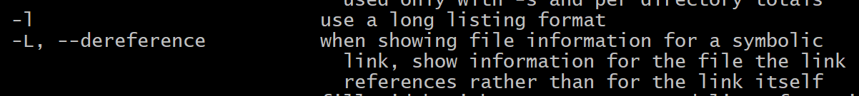

Question 5: (A and B each have 5 points, and C has 10 points. The total is 20 points.)  To respond to this question, you need to use terminal/Bash and have a screenshot of your terminal/bash.

1. Create a folder within your home directory, which was identified in Question 2, and name it 'temp_bash'.
2. Create a new file using the command `touch` and name it `myfile.txt` inside the new folder `temp_bash` and run `ls` to show that the file is inside the folder.
3. Run the `stat myfile.txt` command and explain the information retrieved from the output. Here is an example of what should be included in the output and a brief explanation for each part.

* `Blocks: 0 `                        The number of blocks for the file.
* `IO Block: 65536`      The size of each block.

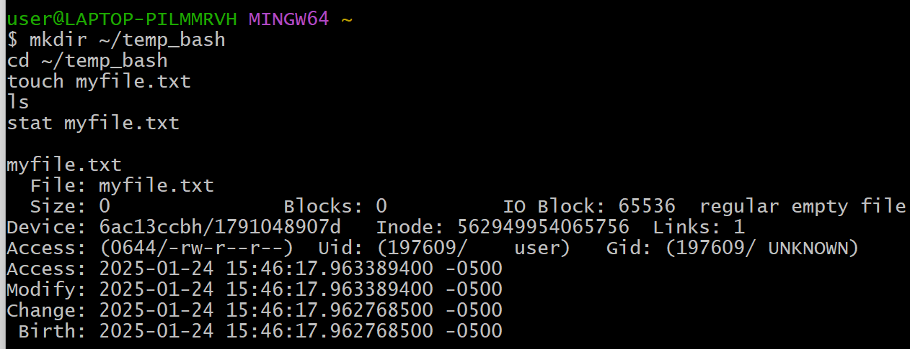

Question 6: (40 Points)  To respond to this question, you need to use terminal/Bash and have a screenshot of your terminal/bash.

1. Use the command `>>`  and add the following line This line is my first line. Now add the following line This line is my second line. Then, run cat myfile.txt to show that the line has been added.
2. Copy the file  myfile.txt to file copy_myfile.txt with the command `cp`
3. Use the command `>`  and add the following line This line is a new line to copy_myfile.txt. Then run cat copy_myfile.txt to show the line is added.
4. Explain the difference between `>` and `>>` based on the result of the Question 6.

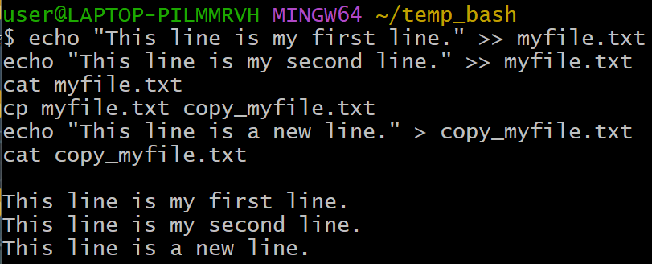

Ans: >> is used to append an existing file and > is used to overwrite an existing file.